Lake Saint Clair

February 2017   
Thurston County Stormwater Utility

# Lake Saint Clair Has Risen 3 Feet in 11 Years

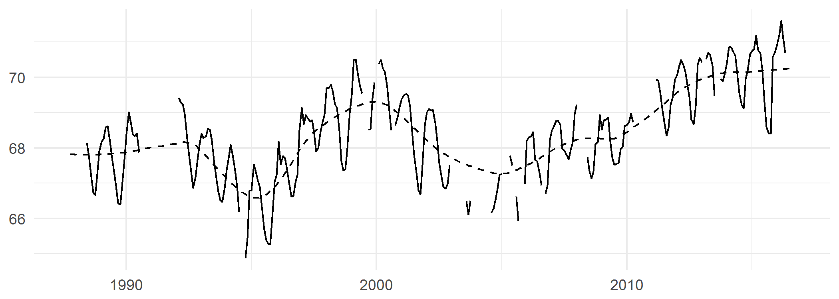

Over the 29 year span from 1988 to 2017, water levels on Lake Saint Clair have fallen to as low as 65 feet[1], and risen to as high as over 71 feet. Since 2005, average water elevations on the lake have been rising, from approximately 67 feet to over 70 feet - higher than the previous peak in 2000.

# Thurston County is Investing in Understanding Lake Saint Clair

While the County cannot control lake elevations, multiple efforts are underway to better understand how and why lake elevations change.

* A new 15-minute water elevation sensor is scheduled for installation in early 2017.
* Ongoing analysis of rainfall data is showing that much of the change in water elevations is linked to long-term precipitation patterns.
* Modeling of the geology and water dynamics in the area continue to reveal new information.

# What Can You Do?

Understand the rules and ordinances governing boating on the lake ([ordinance 16.04.110](http://bit.ly/2l01ehx)) and flood elevations ([FEMA’s National Flood Hazard Layer](http://arcg.is/2jLt9Nt)), and keep up to speed on [lake information and elevations](http://www.co.thurston.wa.us/waterresources/lakes/lakes-st-clair.html).

If you’re worried about losing property or structures, read up on [Ordinance 24.25.300 – Shoreline and slope stabilization](http://bit.ly/2kxAep3).

1. 68.4 feet in NAD 88, the vertical datum used by NOAA in flood maps. Lake Saint Clair elevations are measured in mean sea level, or NGVD 29, as are county ordinances regarding boating restrictions. Flood elevation maps are measured in NAD 88, which is 3.468 feet higher than mean sea level at the Lake Saint Clair gage. Elevations in this document are NGVD 29.